READ PAGES

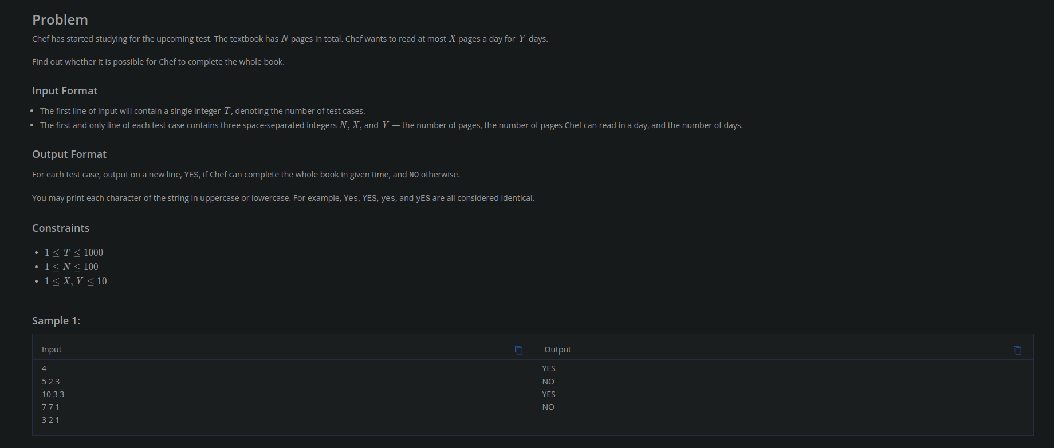

LOGIC:
print “YES” if max hours that the chef can read in the entire time(x*y) is greater than the time needed to complete the book(n)

CODE :
for __ in range(int(input())):
n, x, y = [int(i) for i in input().split()]
if x*y>=n:
print("YES")
else:
print("NO")

400M RACE

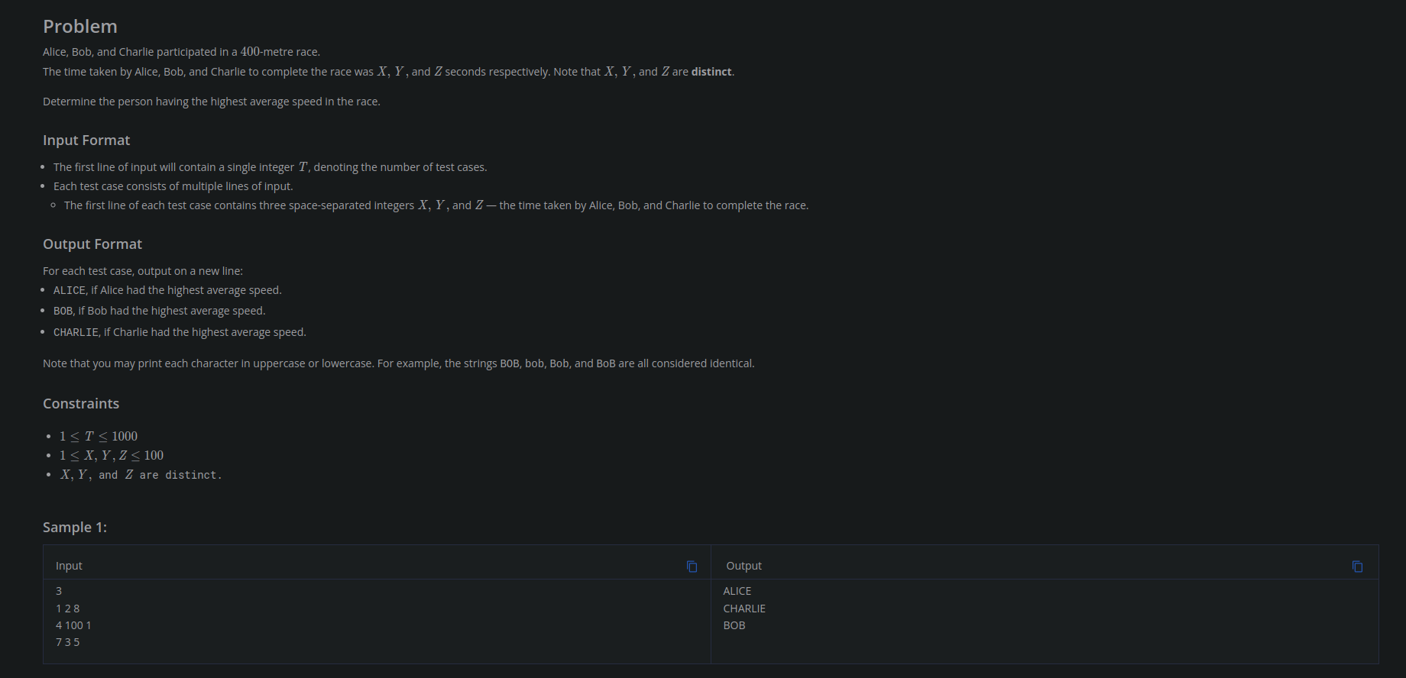

LOGIC:
pace is inversly proportional to time taken... so find the person who completed the race in least time

CODE:
for __ in range(int(input())):
x, y, z = [int(i) for i in input().split()]
m = min(min(x, y), z)
if m == x:
print("ALICE")
elif m == y:
print("BOB")
elif m == z:
print("CHARLIE")

REDISTRIBUTING CHOCOLATES

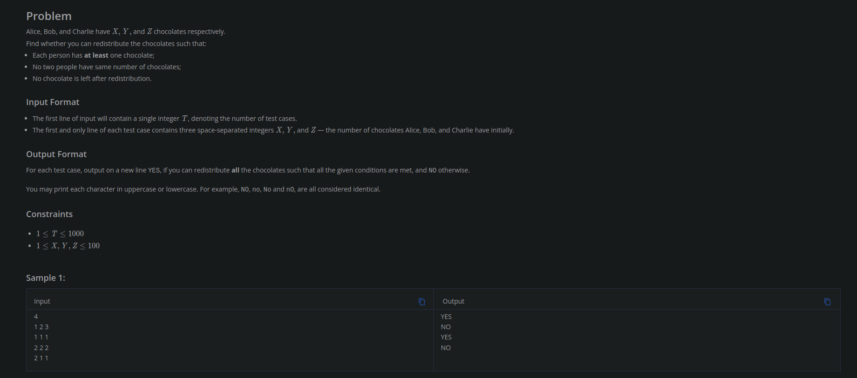

LOGIC:

CODE:
for __ in range(int(input())):
a, b, c = [int(i) for i in input().split()]
s = a+b+c
if s>=6:
print("YES")
else:
print("NO")

